# RASPBERRY PI 4

# 1. INTRODUCTION

The Raspberry Pi 4 Model B, launched in June 2019 by the Raspberry Pi Foundation, marked a significant advancement in the single-board computer (SBC) lineup. It introduced substantial improvements over its predecessors, including a more powerful processor, increased memory options, enhanced connectivity, and support for dual 4K displays. These enhancements expanded its applicability beyond educational purposes to encompass industrial, commercial, and research domains, including space applications.

This document provides an in-depth analysis of the Raspberry Pi 4's specifications, capabilities, advantages, and limitations, particularly concerning its suitability for various satellite subsystems.

# 2. DIAGRAMS AND SCHEMATICS

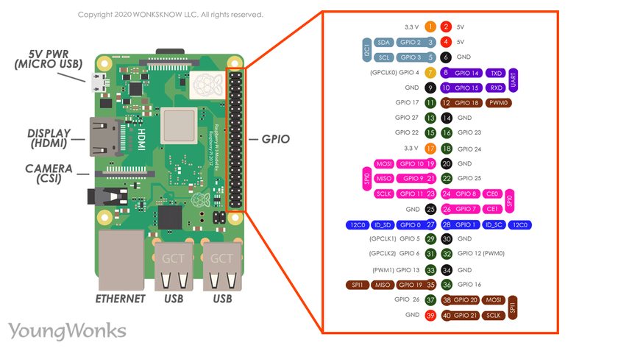

Figure 1: Raspberry Pi 4 GPIO Pinout (40-pin header)

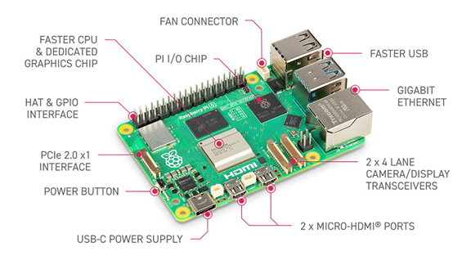

Figure 2: Raspberry Pi 4 Board Layout

# 3. SPECIFICATIONS, CAPABILITIES, AND CHARACTERISTICS

## 3.1. Core Architecture

- System on Chip (SoC): Broadcom BCM2711  
 - CPU: Quad-core ARM Cortex-A72 (ARM v8) 64-bit SoC @ 1.5GHz  
 - GPU: Broadcom VideoCore VI  
- Memory: Available in 1GB, 2GB, 4GB, or 8GB LPDDR4-3200 SDRAM  
- Storage: MicroSD card slot for OS and data storage  
- Networking:  
 - Ethernet: Gigabit Ethernet  
 - Wireless: 2.4 GHz and 5.0 GHz IEEE 802.11b/g/n/ac wireless LAN  
 - Bluetooth: Bluetooth 5.0, BLE  
- USB Ports:  
 - 2 × USB 3.0 ports  
 - 2 × USB 2.0 ports  
- Video & Sound:  
 - 2 × micro-HDMI ports (up to 4Kp60 supported)  
 - MIPI DSI display port  
 - MIPI CSI camera port  
 - 4-pole stereo audio and composite video port  
- GPIO: 40-pin GPIO header, fully backward-compatible with previous boards  
- Power: 5V DC via USB-C connector (minimum 3A)  
- Operating System Support: Raspberry Pi OS (32-bit and 64-bit), Ubuntu, and other Linux distributions

## 3.2. Multimedia Capabilities

- Video Decoding:  
 - H.265 (4Kp60 decode)  
 - H.264 (1080p60 decode, 1080p30 encode)  
- Dual Display Support: Supports dual monitors via two micro-HDMI ports

## 3.3. Power Consideration

Power consumption is a critical consideration in a power-constrained satellite. Empirical measurements show the Pi 4 is far more power-consuming than earlier Pi models. With no peripherals attached, the Pi 4 draws about **2.5 W at idle** (≈0.5 A at 5 V) and can peak around **6.8–7 W** under a worst-case synthetic load. (By comparison, a Raspberry Pi 3B+ draws on the order of 1.5–2 W idle, and the tiny Pi Zero 2 W can idle around 0.6 W.

The Pi 4 does not have a built-in sleep or deep-standby mode like a microcontroller; it remains fully powered unless externally switched off. In practice, the board is either running or completely powered down. Satellites usually must provide a regulated 5 V supply and fuse the input for safety. The official spec is 5 V/3 A, but under typical loads the Pi 4 will draw less (e.g. ~0.6 A idle, up to ~1.4 A heavy CPU). Care must be taken to handle surge currents during boot and any faults.

* **Idle:** ≈2.5 W (0.5 A at 5 V).
* **Under load:** up to ≈6.8 W (1.3–1.4 A at 5 V).
* **Standby:** effectively none (no low-power mode without custom hardware).

# 4. ADVANTAGES AND DISADVANTAGES

## 4.1. Advantages

- Enhanced Performance: The quad-core Cortex-A72 processor and increased RAM options provide significant performance improvements over previous models.  
- Improved Connectivity: Inclusion of USB 3.0 ports, Gigabit Ethernet, and dual-band Wi-Fi enhances data transfer and networking capabilities.  
- Dual 4K Display Support: Ability to drive two 4K displays simultaneously expands its use in multimedia applications.  
- Backward Compatibility: Maintains compatibility with accessories and GPIO pins from earlier models.

## 4.2. Disadvantages

- Lack of Radiation Hardening: Components are not designed to withstand space radiation, posing risks of malfunction in orbit.  
- Thermal Management Challenges: Higher performance leads to increased heat generation, requiring effective thermal management solutions, especially in vacuum conditions.  
- Power Consumption: Higher power requirements may be challenging for power-constrained satellite systems.  
- Non-Real-Time Operating System: Standard Linux distributions are not real-time, which may not be suitable for time-critical applications without additional configurations.

# 5. SUITABILITY IN SATELLITE SUBSYSTEMS

## 5.1. Telemetry, Tracking, and Command (TT&C)

While the Raspberry Pi 4's enhanced networking capabilities could be advantageous, the lack of radiation hardening and real-time processing may compromise reliability in TT&C applications.

## 5.2. On-Board Computer (OBC) / Command and Data Handling (C&DH)

The increased processing power and memory make it suitable for handling complex tasks; however, concerns about reliability in space environments persist.

## 5.3. Electrical Power System (EPS) Control

Higher power consumption and non-real-time OS may not be ideal for managing power systems that require precise control and low power usage.

## 5.4. Communication (Payload Data Downlink / Inter-Satellite Links)

USB 3.0 and Gigabit Ethernet support high data rates, beneficial for payload data handling. Nonetheless, environmental vulnerabilities must be addressed.

## 5.5. Ground Stations

In ground-based applications, the Raspberry Pi 4's features are highly beneficial, offering a cost-effective solution for data processing and communication tasks.

## 5.6. Attitude Determination and Control System (ADCS)

The lack of real-time processing and environmental robustness makes it less suitable for critical ADCS functions.

# 6. CONCLUSION

The Raspberry Pi 4 Model B represents a leap in performance and features within the Raspberry Pi lineup. Its enhanced processing capabilities, memory options, and connectivity make it a versatile tool for various applications. However, for satellite subsystems, especially those requiring high reliability and resilience to harsh environmental conditions, the Raspberry Pi 4's limitations, such as lack of radiation hardening and real-time processing, must be considered. It may be best suited for non-critical functions or ground-based support systems where its advantages can be fully leveraged without compromising mission integrity.